SYSTEM USECASE DIAGRAM

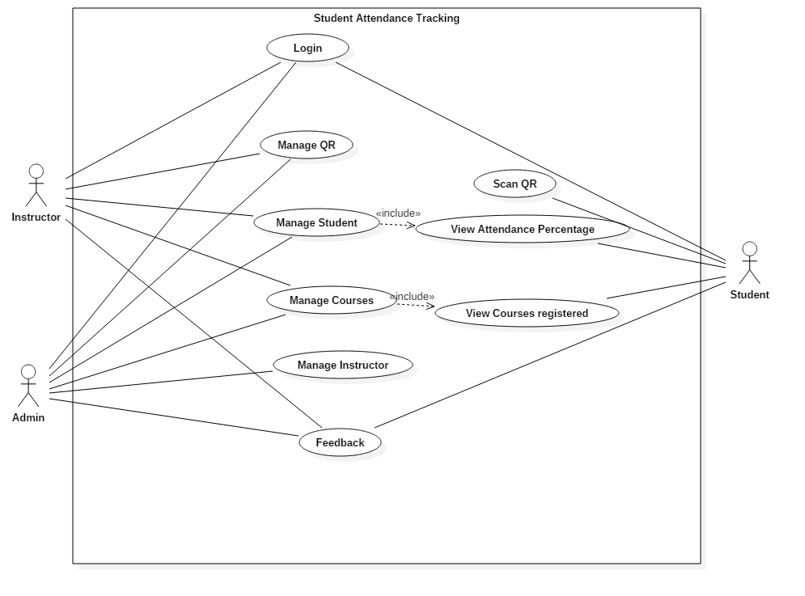

**Figure1: System Use case Diagram.**